Software Guide

* The most recent version of the labeler is the “BackgroundCapableLabeler.py”
* 3 Input Files that the labeler utilizes to create the final data sets:
  + PRF – flight instances (provided file) use the provided file in order to have the columns line up. The labeler uses the first and third column: esn and date, to match up the flight days
  + FLT – error instances (provided file) use the provided file in order to have the columns line up. The labeler uses the first and third column esn and date, to match up the error instance with the flight day and the 8th and 9th columns to track the error associated with it.
  + ErrorCodes – Created file with grounding errors. Must have no column headers and from right to left: error code number, error code name, description, error severity. 2 = grounding and 0 = non-grounding.
* If these files are in the same folder as the labeler and have the corresponding names you can use the default button. 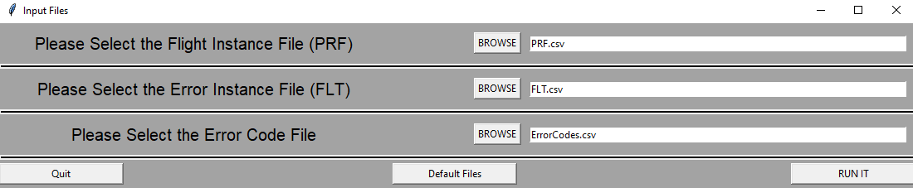
* Then you click the run button to begin the process.

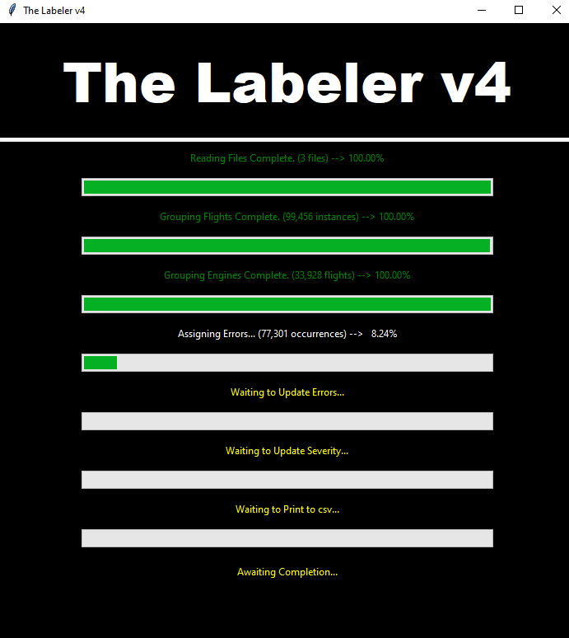

* The progress bar will pop up and run during the process. Each bar is one step of the process which is laid out in more depth in the commented code.
* At the end of the run of the procedure the progress bars will be filled and the “Open Output Folder” button will be presented.

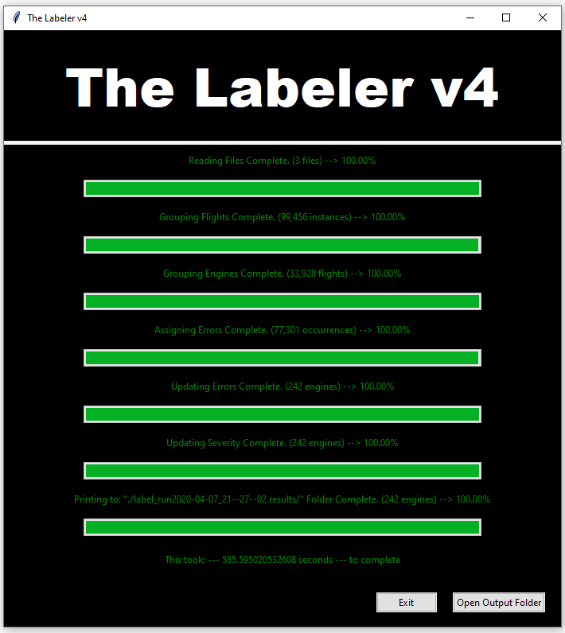

* The output folder will be placed in the same folder that the labeler is in currently.
* When opened there is a collection of 7 files with different names:
  + Eg_eval_labelrun, eg_test_labelrun, eg_train_labelrun
    - These are the smaller groups of the data set that are assigned by assigning random numbers to each engine and placing all entries corresponding to that engine in its respective data set.
  + Fg_eval_labelrun, fg_test_labelrun, fg_train_labelrun
    - These are the smaller groups of the data set that are assigned by assigning random numbers to each flight and placing each in the corresponding data set.
  + Labelrun
    - This is the entire dataset with all assigned instances.
* Further details about this can be found in the commented code that makes up this software.